RESOLUTION NO.__________

RE: CERTIFICATE OF APPROPRIATENESS UNDER THE
PROVISIONS OF THE ACT OF THE PENNSYLVANIA
LEGISLATURE 1961, JUNE 13, P.L. 282 (53
SECTION 8004) AND BETHLEHEM ORDINANCE NO.
3952 AS AMENDED.

WHEREAS, it is proposed to replace the garage roof with a new gable roof at 428 High Street.

NOW, THEREFORE, BE IT RESOLVED by the Council of the City of Bethlehem that a Certificate of Appropriateness is hereby granted for the proposal.

Sponsored by:_

ADOPTED BY COUNCIL THIS DAY OF , 2016.

President of Council

ATTEST:

City Clerk

HISTORICAL & ARCHITECTURAL REVIEW BOARD

The applicant proposes to remove the garage roof and replace with a new gable roof at 428 High St.
APPLICATION #3:

Mark & Kathleen Jobs
428 High St.
Bethlehem, PA 18018

OWNER:

__________________________________________________________________

The Board upon motion by Phil Roeder and seconded by Connie Glagola adopted the proposal that City Council issue a Certificate of Appropriateness for the following:

- New gable roof structure will be GAF slateline shingles.

2. Color scheme for trim and siding to match existing house.

3. New half round gutters and round aluminum downspouts painted to match the
trim color.

4. The motion was unanimously approved.

__________________________________________________________________________

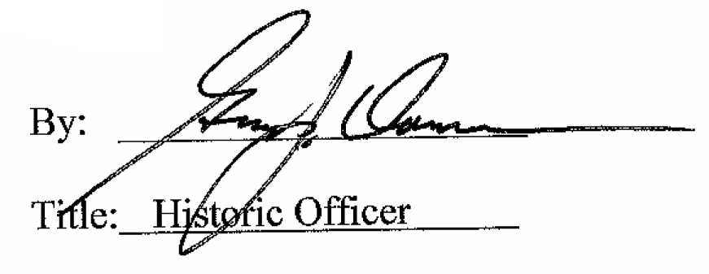

Date of Meeting: April 6, 2016

